**Faculty of Computing**



**Lab # 1 Task 1,2&3**

Computer Architecture

Lab Instructor: Ayesha

Name: Mahnoor Farrukh

SAP ID: 52926

Semester: BSCS-4

Task 1:

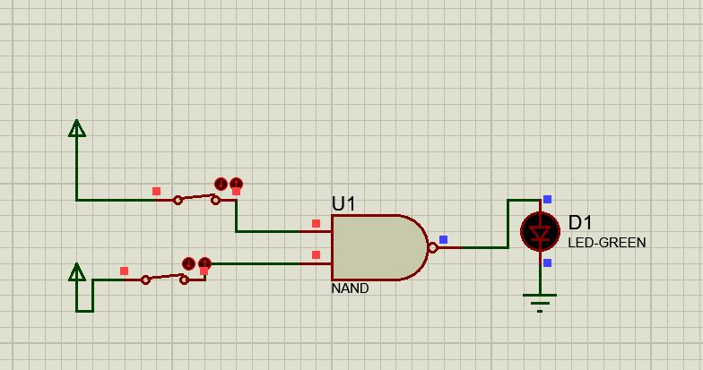

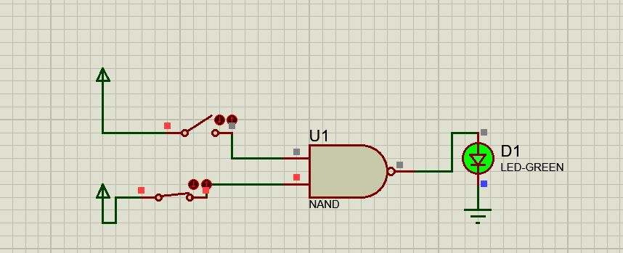

Task 2:

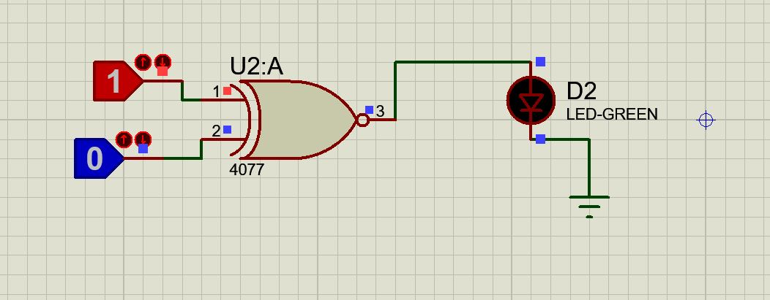

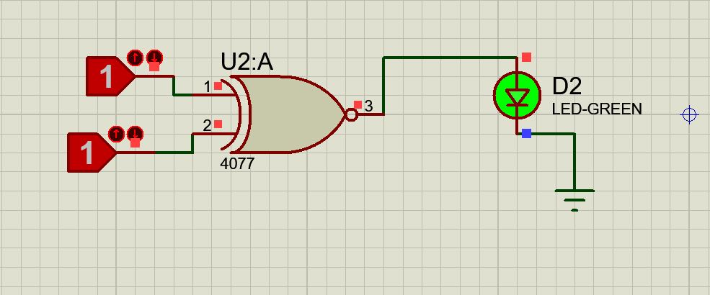

Task 3:

